**Main Manuscript for**

**Distortions in Representation: A Complex Systems Perspective**

Samuel S.-H. Wang*1, Jonathan R. Cervas2, Bernard Grofman3

1Neuroscience Institute, Princeton University, Princeton, New Jersey 08544 USA. ORCID: 0000-0002-0490-9786

2Institute for Politics and Strategy, Carnegie Mellon University, Pittsburgh, Pennsylvania USA. ORCID: 0000-0001-9686-6308

3Department of Political Science, University of California, Irvine CA USA. ORCID: 0000-0002-2801-3351

*Corresponding author:

Sam Wang

Neuroscience Institute, Washington Road

Princeton University

Princeton, NJ 08544

(609) 258-0388

sswang@princeton.edu

**ABSTRACT**

**In the United States, distortions in representation can privilege a faction of voters at the expense of the majority and facilitates polarization which makes it impossible for moderate voters to have moderate options available to them. Distortions can occur at multiple levels, from limits on who can vote, to making it harder to vote so that electorates are unreflective of public opinion, to how votes are translated into outcomes. The latter includes both choice of voting rule and procedures for districting that enhance the potential for gerrymandering that can generate partisan or racial bias or create seats whose legislators need respond to only the dominant group in their constituency. Money in politics can also cause distortions. Here, after a general overview of the literatures on polarization and electoral distortion, we focus on a select set of reforms to electoral institutions: ranked-choice voting, open primaries, and changes in the way in which redistricting is conducted. Taking a complex systems approach familiar in engineering and biology, we recognize the existence of feedback loops with distinct dynamical properties of long-term interaction that link polarization and partisan sorting at the legislative level and at the candidate level and at the activist level and at the mass level, and we acknowledge the importance of intervening factors such as the degree of political competition at different levels of government. We also emphasize that institutional reforms are not a panacea; they rarely have the massive effects anticipated by reformers and they also may have unintended negative consequences, but they do have the potential to create a new reform dimension that might allow for cooperation across party lines.**

**Significance Statement**

*We suggest that a complex systems-based theory provides a natural vocabulary for evaluating the effectiveness of electoral reform in the United States. The mechanisms we describe interact in a complex manner to drive representational outcomes. Positive feedback steps take on outsized importance. When the median voter is not the pivotal voter, within-party processes work to elect more extreme politicians, and to effect which voters get their preferences realized in public policy outputs. Current reforms are aimed at disrupting distorting and polarizing processes.*

**THE SCIENCE AND ENGINEERING OF REPRESENTATIVE DEMOCRACY**

The complex nature of U.S. institutions offers multiple pathways for distortion of representation, a situation where the preferences of the majority are bypassed. Current ideas for reform include changes in suffrage (e.g., an end to ex-felon disenfranchisement), eased access to voting (e.g., permanent registration, mail ballots, making election day a national holiday), changes in how judicial selection is done, changes in campaign financing,[1] and changes to electoral rules (e.g., the use of ranked-choice voting for general elections, changes in the rules for party primaries, and redistricting reform), to name just some of the most prominent. Here we focus on a few electoral reforms that might have substantial leverage, the last three of those listed above. However, the perspective based on complex systems that we offer emphasizes that any given reform is institutionally embedded in a complex dynamical system of feedback loops. Thus, no matter how well-intended such reforms may be, their consequences are not always easy to predict.

In engineering or biology, one often encounters complex systems of interacting parts. Systems may be designed, such as a power grid or a mechanical clockwork, or arise through selection mechanisms, such as animal population dynamics or the evolution of new species. In both cases, a full understanding of a system’s behavior requires understanding both individual rules, network interactions, and the effects of exogenous factors. A complex-systems approach reinterprets the science of politics in terms of the conceptual goals of engineering. Government arises from a combination of designed and naturally-arising features that include institutions, demographics, and geographic variation. We suggest viewing the U.S. system of representative democracy in terms of how its features interact to form a complex system. An engineering-inspired approach seeks to assess the emergent behavior that arises when such features work together, identify nonlinear interactions, and help understand events that go outside past experience.

Understanding feedback loops and hysteresis effects[2] are critical to understanding a complex system.

For example, confirmation of judicial appointments used to require the approval of both of an appointee’s home-state Senators as well as supermajority support on the floor of the Senate; now, confirmation votes now routinely follow partisan lines and require only bare-majority support. The long-lasting nature of judicial appointments creates a hysteresis effect which increases incentives for legislators and the President to intensify polarized conflict. Indeed, any institutional rules that would give a long-lasting advantage, such as lifetime judicial appointments, provide an incentive to engage in hardball tactics. As judicial appointments take on outsized importance because the fight about then is both bitter and partisan, they in turn become an issue that motivates polarization, thus creating a feedback loop.

Another feedback loop involves the link between gerrymandering and polarization of legislators (Merrill et al., 2014). Gerrymandering protects incumbent legislators from voter opinion. Party loyalty in polarized conditions is high, and districts are easily drawn to be safe in the general election since relatively few voters “swing” (Gelman et al 2016). Conversely polarization increases the incentives for gerrymandering. Under polarized conditions, a political party will be less willing to share control with the opposition, and more prone to draw lines aggressively to maximize the number of seats held. Thus, polarization leads to "go for broke" willingness to do anything to maintain power, including egregious gerrymandering. With so much at stake, tactics may take a more confrontational tone of “Constitutional hardball” (Tushnet 2004) in which governing norms are broken and rules are bent, especially in the service of gaining advantage. But incivility and norm violation by one side will ultimately be met with further incivility and norms violation when the other side returns to power. Thus, egregious gerrymandering in turn fosters a contentious and distrustful environment in which polarization is made more likely.

Of course, other features of the political environment can impact the degree to which egregious partisan gerrymandering is going to be an attractive choice. One factor is the legal environment. When the Supreme Court has declared partisan gerrymandering to be non-justiciable in 2019, likelihood that the 2020 redistricting round would see the worst partisan gerrymandering ever went way up. Another factor is the degree to which elections are competitive at the national, the state, and the district level. When the two parties are closely divided in strength, as they have been for the last 20 years, substantial advantage comes from small gains in support that lead to a change in control of government, thus close divisions, especially when trifecta control is seen as a possibility, exacerbate polarization (Lee 2016), and polarization can in turn freeze electoral divisions in a way that may perpetuate close elections.[3]

**POLARIZATION, SORTING AND CROSS-ISSUE HOMOGENEITY AND THEIR INTERACTION WITH RACE AND GEOGRAPHY**

**Root causes of voter polarization.** Central features of modern U.S. politics are (1) polarization, with bimodality of opinions on issues and a high standard deviation; (2) increased cross-issue correlation, so that there are fewer voters or legislators who are cross-pressured in their choice among policy platforms, thus creating increasingly unidimensionality of political competition; and (3) the sorting of voters and legislators into parties so that the parties are increasingly homogeneous with respect to any given issue and in overall ideological terms. At the level of public officials and activists there is incontrovertible and dramatic evidence for all three phenomena. At the mass level, there is compelling evidence for sorting, strong evidence for growing cross-issue correlations, and limited evidence for strong polarization, with the mass electorate still remarkable unimodal on issues (Fiorina, 2017). Moreover, and increasingly, the mass electorate is polarized on beliefs along partisan lines (Leonard et al 2021, PNAS).

Ideological lines have hardened, with partisans holding correlated issue positions across seemingly independent issues such as environmental protection, immigration, taxation, and gay marriage (Fiorina and Abrams 2008). Voters who identify as Republicans have very different beliefs than Democrats on factual matters such as the extent of racial discrimination, evidence for global warming (Tesler and Sears, 2010), and fictitious claims of fraud in the 2020 election (Quinnipiac 2020). These divisions are accompanied by a rise of negative partisanship (Abramowitz and Webster 2018), *i.e.,* the dislike of the other political party, and a rise in “affective polarization”, *i.e.,* greater dislike of the other party(Iyengar et al. 2019),[4] including an increase in the percentage of parents unwilling to see their children marry across party lines (﻿Iyengar, Sood, and Lelkes 2012).[5]

The tendency toward single-dimension ideology is facilitated by the US system of single member districts, which creates strong incentives to reduce party structures to two major competing choices (Duverger 1954); but the degree of polarization and sorting has changed dramatically since the 1970s (McCarty, Poole, & Rosenthal 2008).[6] Thus, institutions cannot explain polarization, since the recent increases in polarization occurred without major changes in the rules of democracy.

There are many explanations offered for the rise in polarization and sorting, including changes in the structure of political communication (Chan 2020) that limit exposure to conflicting views and increase exposure to new types of media with highly skewed views (Tokita et al 2021, PNAS). Such persuasion processes are tied to social network effects (Feldman et al. 2021) and biased media sources that create an echo chamber effect (Santos et al 2021, PNAS), which serves as mutually reinforcing. Moreover, discreditation/misinformation campaigns can foster distrust with mainstream media sources and with “experts ” and scientific evidence more generally, as well as great distrust of those of opposing political views (Wattenberg 2004; Prior 2007, 2012; Groeling 2008). Distrust leads respondents to reject the views of sources that offer positions or beliefs too far away from themselves, and to increase distrust of such sources. Indeed, such “backlash” forces can actually lead to reinforcing pre-existing views in the face of contrary evidence/arguments from what have become distrusted sources (Axelrod, Daymude and Forrest2021, PNAS). Cross-correlation of issues also can exacerbate polarization (Szysmanksi et al. 2021, PNAS).

Another potential cause of/reinforcer of polarization highlighted by other scholars is fear among non-Hispanic Whites about demographic change that leads them to a lessening of a sense of shared civic identity. The population structure of the nation has been reshaped profoundly by the Hart-Celler Immigration and Naturalization Act of 1965. Overall, the Democratic party is becoming a coalition of ethnic minority groups and the college-educated and tilting toward women. The Republican Party has become an almost entirely white, mostly non-college-educated group. The overall result is an ethnicized party system.[7]

Another factor seen an enhancing polarization is increasing economic inequality (Piketty and Saez, 2003; Duca and Saving, 2016; Stewart, McCarty, and Bryson 2020). This inequality is reflected in a decline in the well-being of the poor and loss of hope in the American dream for the middle class (Putnam and Garrett, 2020).

There is also an institutional feedback loop that exacerbates polarization, involving the ideological distance between the parties at the national level and the degree to which candidates of each party offer platforms that are distinct and simply match the national party platform rather than being adapted to the characteristics of the local constituency whose median voter must be won over. Contests for the U.S. Congress have become increasingly nationalized, so that the destiny of a candidate for federal office is tied to national political forces (Abramowitz and Webster 2016; Carson et al. 2019; Jacobson 2019). But much less well understood is that the tightness of the national party constraint on congressional candidates has varied over time in a way that is inverse to the degree of congressional polarization. As congress grows more polarized, the gap between candidates of opposite parties grows, which means that extremists are more likely to be elected (Adler and Broockman 2018), which means the gap between candidates of opposite parties will again grow, etc. (Merrill et al. 2014, Brunell et al. 2016) -- so that, in their words, at an institutional level, “polarization begets polarization.”[8]

Finally, while usually we think of polarization in ideological terms, or perhaps in terms of the structure of beliefs, another useful way to think about polarization is in terms of geography.

Despite the reduction of dimensionality of politics to a single polarized axis, one feature has remained heterogeneous: geographic variation in political stances. Political polarization has a spatial dimension (Chu et al 2021, PNAS) that is linked to representational distortions. There are two geographically linked patterns to which we wish to call attention: the urban-rural divide and regional patterns of polarization.

**The urban-rural divide.** Which states are safely Democratic or safely Republican have varied considerably over the last 100 years. Despite those shifts, a consistent trend emerged starting around 1960, namely a rising correlation between population density and partisan preference (see **Figure 1**).[9]

**Figure 1. State-by-state correlation between partisanship and population density, 1868-2020 (Spearman rank order correlations)**

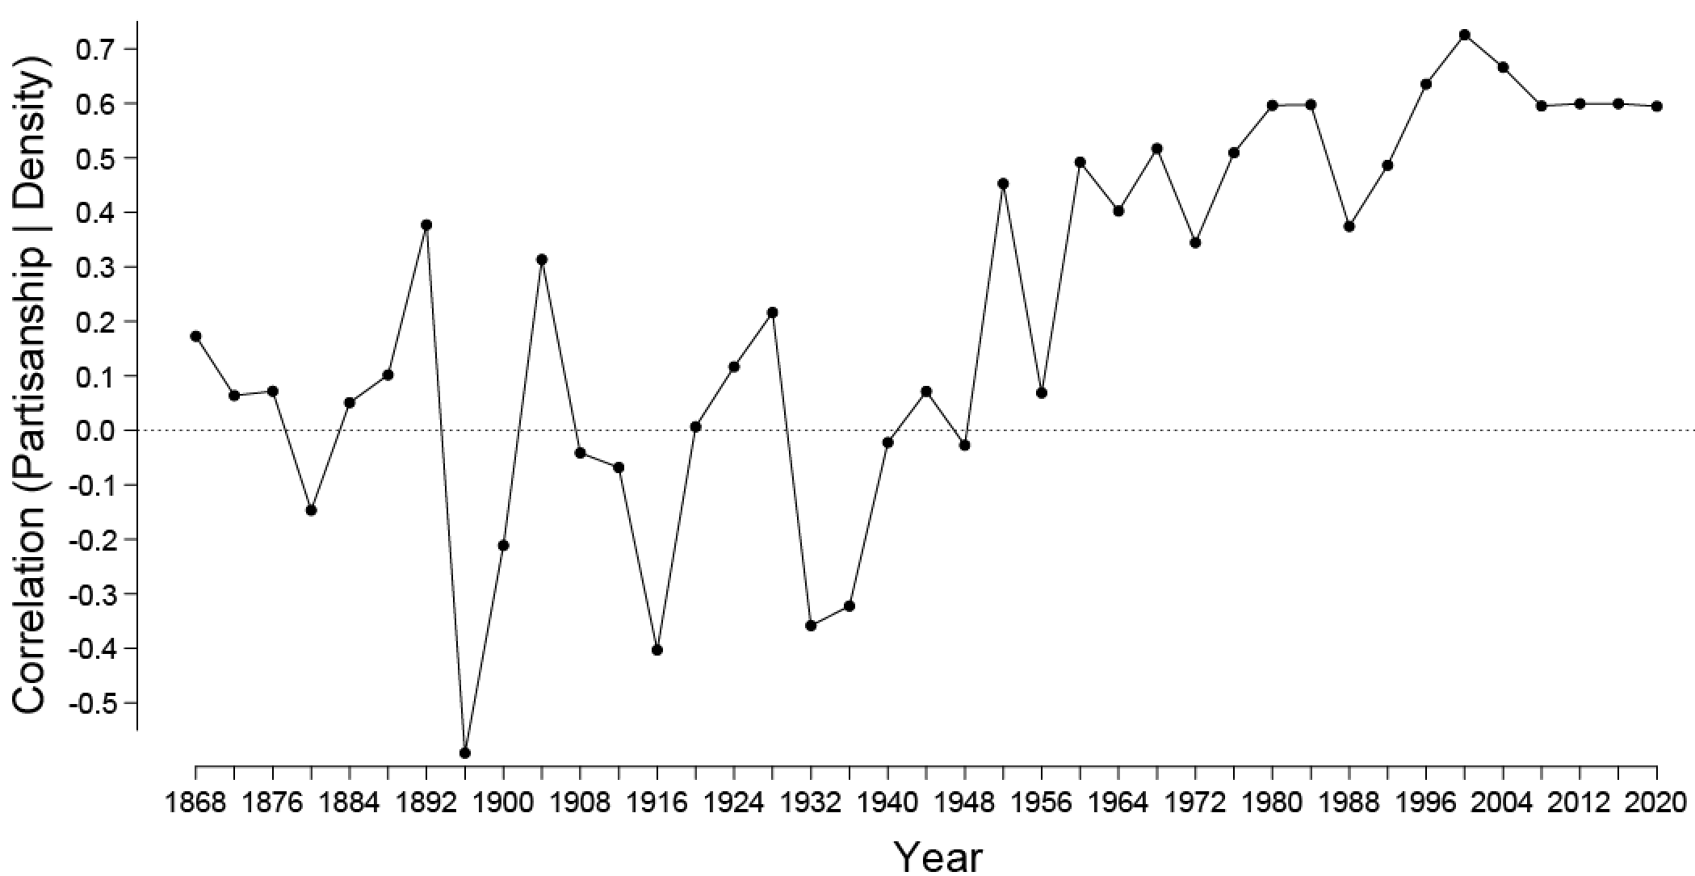

**Regional Polarization. Figure 2** shows maps from 1900 and 2020 that reveal the remarkable reversal in the geographic bases of party support, but the continuation of patterns of geographic polarization. However, because these figures look only at which party is above the median, they do not show another important phenomenon, the increase in the number of states won by very large margins (figure omitted for space reasons).

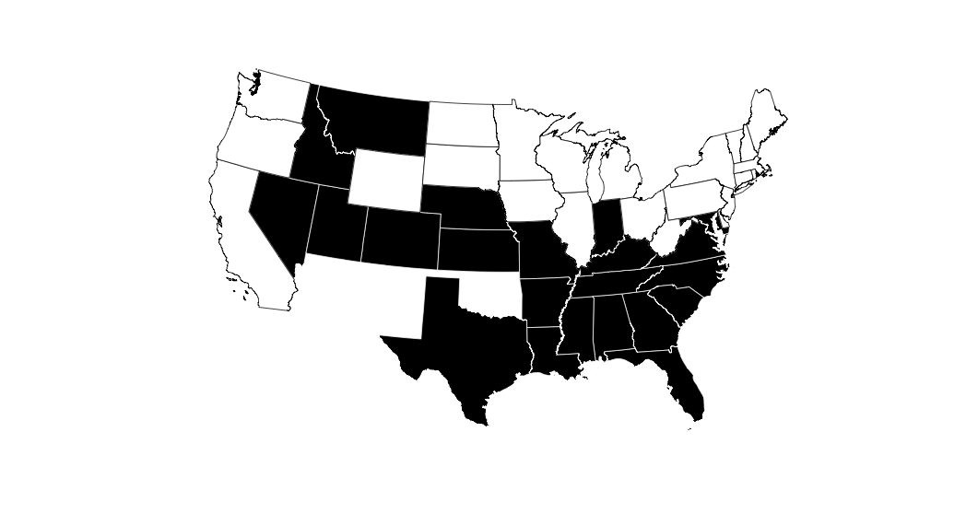

**Figure 2a States with Democratic Vote Share above the Democratic Median Vote Share in the 1900 Election**

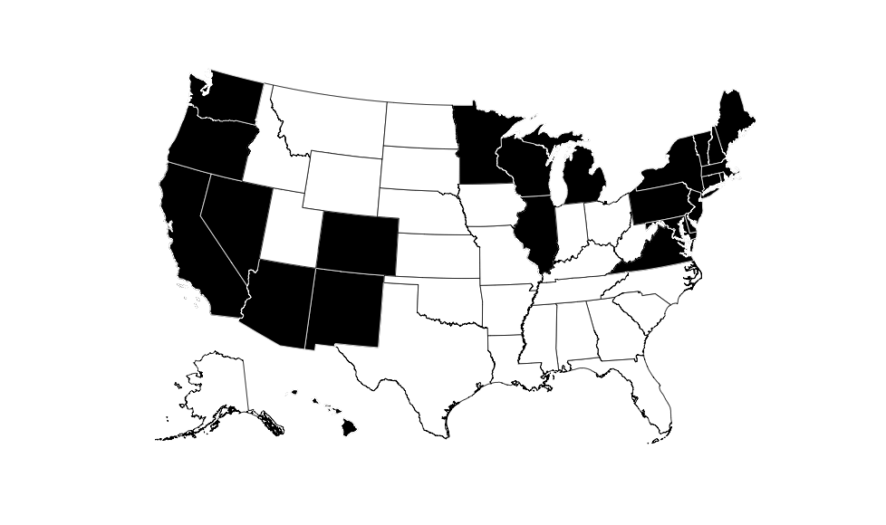

**Figure 2b States with Republican Vote Share above the Republican Median Vote Share in the 2020 Election** **JONATHAN YOU WILL NEED TO REVERSE THE COLORS ON THIS MAP**

**MANIPULATING INSTITUTIONS TO MAINTAIN PARTY CONTROL AND TO PREVENT THE MEDIAN VOTER FROM PREVAILING.**

Modern democratic theory (Downs 1957) posits that the median voter should be the one whose policy preferences are realized. Yet, representational distortions cause the median voter to be bypassed, with the pivotal legislator often much more extreme than the median voter, or the median voter or legislator is forced to make a choice between two extreme options (Krehbiel 1998). Drawing on the political science literature we can identify various sources of representational distortions in this complex system of U.S. political institutions.

Short term partisan advantage can come from manipulations that make it more difficult for potential/likely supporters of the other side to vote (through mechanisms such as making it harder to register and restricting the times and places of casting ballots, or purging voters in a fashion that is discriminatory).[10] Advantages coming from egregious partisan gerrymandering that have effects that extend into the next redistricting cycle, or from lifetime appointments to the judiciary in which appointments by the other side are deliberately blocked, can produce effects that are very long-lasting. Even longer run effects come from excluding millions of potential voters more or less permanently from suffrage by denying the vote to ex-felons who have served their time in prison but who are still denied the rights of citizenship.[11] We may see these manipulations as attempts to hold back the tide of natural forces of demographic and social and political change.

**Electoral distortions in the Senate, the House and the Electoral College**.

To quickly understand representational distortions at the national level there are three numbers to remember: **46, 48, and 48.** These are the shares of the popular vote the Republican candidate(s) could get for the Senate, the House, and the Electoral College, respectively, and still win control of that institution.

**The Senate.** The pattern of greater Republican strength in the less dense (and the less populous) states (see Figure 1) gives advantages to Republicans because their votes are distributed to win more states for the same national popular votes. For example, ca. 2020, it appears that Democrats need at least XX % of the national vote for Senate over the course of three elections to win a majority of the Senate. Indeed, Republicans might even be able to win 60 out of the 100 Senate seats with only XX% of the popular vote.

**The U.S. House of Representatives**. Every 10 years, Congressional and state legislative boundaries must be redrawn in response to Congressional apportionment and to equalize district populations within a state. In most states, redistricting is under the control of legislatures and the governor, who must work together to draw lines, as well as follow federal and state legal requirements. Every state has its own process (National Conference of State Legislatures, 2020). Redistricting is particularly susceptible to representational distortions. Geographic patterns of immigrant location (Massey 2007), and the continuing economic decline of rural areas have meant that Democratic cities face a Republican countryside, with the areas “in play” mostly suburban ones (Rodden 2019). Because minorities and higher education voters are largely concentrated in cities, there is a natural partisan advantage to Republicans in congressional and state level redistricting, since Democratic voters are concentrated. For example, at the congressional level, in Philadelphia, it is almost impossible not to draw some districts that are at least 80% Democratic unless one is prepared to fragment the city in an amoeba-like fashion (Cervas and Grofman, 2020b). But, important as is so called “natural gerrymandering,” almost all the representational distortional effects are manmade.

We know that the primary locus of extreme gerrymandering are *trifecta states*, i.e., states where the control of redistricting is in the hands of one party. In the 2000 round and even more so in the 2010 round, this control was disproportionately in the hands of the Republican party. **Figure 3** shows how anti-Democratic distortion in seats-vote relationships caused by gerrymandering for the U.S. House has gotten worse in the 21st Century, with the more limited pro-Republican bias in the House in 2020 in part due to changes involving congressional districts that had been redrawn by courts.[12] In 2020, we will again have disproportionate ability to gerrymander in Republican hands, mores so even than in the 2010s, which was previously the record holder for the most gerrymanders and the most egregious ones. In 2020, Democrats have the ability to dominate line-drawing in six states, while Republicans have control in seventeen states. In addition, the Democratic governor has relatively little say over redistricting in two states with Republican-controlled legislatures, North Carolina and Kentucky.[13] Moreover the distortions from 2010 era redistricting can largely perpetuate themselves in the form of incumbency advantage. Like the legendary Baron Munchausen, legislators lift themselves up by their own bootstraps to stay in office more or less indefinitely, a powerful hysteresis effect.

A further complication in understanding gerrymandering is the confound between racial and partisan gerrymandering (Hasen 2018). Since most minorities are overwhelmingly Democrat, Republicans can achieve partisan gain through manipulation of racial populations. Mechanisms for constraining racial gerrymandering have been weakened by *Shelby County v. Holder* (570 U.S. 529, 2013), a case that effectively struck down the racial protections of Section 5 of the Voting Rights Act. Further erosion of the Voting Rights Act, particularly Section 2 of the Act, will make racial gerrymanders even easier to commit. And since the Supreme Court has declined to get involved in partisan gerrymandering cases (*Rucho v. Common Cause* 588 U.S. ___, 2019), any racial gerrymander is likely to be defended by calling it a partisan gerrymander. Moreover, in a case pending at the time of this writing (March 2021) the current Supreme Court may determine that, when it comes to racial gerrymandering, few, if any constraints apply.

|  |
| --- |
| **Figure 3. Distortions in Congressional Representation 1946-2020**  Note: The black dots represent U.S. congressional elections from 1946-2010. They are shaded by a convex-hull , where the first four elections in the 2010 decade are beyond the frontier completely. Even including 2020, the 2010 decade of elections represents a significantly increased partisan bias over the previous 64 years. |

**The Electoral College.** Although the two-state bonus alone only rarely affects who wins, partisan bias in the Electoral College is similar to that in the Senate and caused largely by the geographic distribution of partisan voting strength. What is most striking is how that bias has grown in a pro-Republican direction in the last two elections (Cervas and Grofman 2020a; Erikson et al 2020). A Republican who wins 48.5% of the two-party votes still has a 50% chance of winning the Presidency.

**MAKING THINGS BETTER**

Formal institutions are both mutually embedded and embedded in wider society. A central design challenge arises from the fact that the wider society undergoes continual change. In the United States of 1790, voters comprised white male landowners and slaveowners in a nation of 4 million. Today, in a nation of 330 million, nearly all adult citizens can, in principle, vote. The institutions of yesterday may not be appropriate for the problems of today. But costs and benefits of electoral rule change may depend on the specific political culture of a jurisdiction, including the degree of partisanship, level of citizen engagement, and diversity (Stewart et al 2021, PNAS). Moreover, while all can agree that electoral rules have important effects, the size and durability of those effects is much more open to dispute. And, there are multiple criteria according to which a reform can be graded, not all of which will yield consistent evaluations.

In the face of record distrust and dissatisfaction with American institutions, interest in reform measures has exploded. That interest parallels in many ways what was seen in the late 19th and early 20th century, where electoral reforms included the secret ballot, women’s suffrage, popular election of U.S. Senators and the implementation of new tools such referenda, initiatives and recalls (Putnam and Garett, 2020). Advocacy for proportional representation was found in the period between the world wars (Hallett 1984), with renewed interest in the civil rights era, where PR and semi-PR methods (cumulative voting, the single non-transferable vote) have been used as remedies for voting rights violations in local jurisdictions (Guinier 1994). The current crop of suggested US reforms includes reforms for general elections such as the instant runoff (ranked-choice voting); reforms for primaries, such as open primaries, top-two or top-four primaries, or approval voting; and reforms of the Electoral College.

**Reform 1: Better decision rules for selecting winners.** The most common rule for electing legislators in general elections in the United States is by plurality a.k.a. first-past-the-post. Under this rule, winners are only guaranteed to command majority support if there are two candidates. And if the available viable candidates, of which there are usually two, represent extreme ideological positions, a legislator with extreme views is guaranteed election (Bafumi and Herron 2010). One broad category of electoral reform seeks to generate outcomes that elect majority winners (a.k.a. *Condorcet winners*), *i.e.*, candidates who would win every one-on-one pairing with individual opponents (Grofman and Feld, 2004). An increasingly popular reform aimed at this outcome, though not guaranteeing it, is ranked-choice voting (RCV; also known as instant-runoff voting or the alternative vote). RCV requires voters to rank the alternatives. In a common implementation, if no alternative receives a majority of first place votes, then the candidate with the fewest first place preferences is dropped and her votes are assigned to the next candidate on the preference list of the voters who ranked her first. This process continues until a candidate receives a majority of the votes on the still eligible ballots.

RCV in single seats constituencies is argued to have a number of specific advantages.[14] Fundamentally, RCV allows voters flexibility to show support for a candidate unlikely to win without hurting the election chances of a less preferred candidate who has a higher likelihood of electoral success, and without inadvertently helping an even less-preferred candidate. RCV may also temper extremism by motivating candidates to appeal to the center. Finally, RCV makes minor parties a viable choice for voters, who can send a message without wasting their votes – with the potential of making the minor party more competitive in future elections. Several distinguished scholars have endorsed RCV (e.g., Sen and Maskin, 2018). But there remain issues. For example, while RCV can foster the election of moderate candidates, this is not guaranteed, since a centrist candidate who is acceptable to most voters is sometimes nonetheless eliminated in early rounds (*cf.* Fraenkel and Grofman 2004, 2006). Nonetheless, even if RCV does not change outcomes, it may diminish negative campaigning and make future compromise easier. Important questions remain, such as do voting rules such as RCV deter voter participation because of the need to rank order multiple candidates on theballot (McDaniel 2016),[15] or do some voters choose to cast incomplete ballots, thus vitiating many of the supposed benefits of this system? These are empirical questions that need to be investigated.

But, in the U.S., the general election is not the only election and it may not be the most important election in areas where the partisan outcome is foreordained. We have a two-stage election process with party primaries the most common method of choosing party candidates. In a partisan primary election there may be many candidates; case the nominee usually can prevail with less than half of the vote, and need only appeal to those members of her own party who bother to vote in the primary -- usually more activist voters. Through primaries, rank-and-file party members can reward loyalty to the party’s issue positions and tone, thus perpetuating polarization. Because of this, a cohesive minority, including one composed of extremists, may potentially determine one or both nominees. With plurality voting for general elections and partisan primaries, the pivotal voter in determining a winner is often different from the median voter

Various reforms have been proposed to the primary process including opening up primaries to allow nonmembers of a party to vote, merging party primaries to a single nonpartisan top-two or top-four system, and various voting rules such as approval voting. But, while allowing all voters to participate in party primaries that are open in some fashion is likely to produce fewer extreme candidates than closed primaries, the size of the difference is unresolved (McGhee, Masket, Shor, Rogers, and McCarty 2014; Grofman, Troumpounis, and Xefteris 2019). Such open primaries also carry the risk of abuse by voters from outside the party acting in bad faith.

This proliferation of alternative voting systems, many of which are already being used somewhere in the United States, offers a rich agenda for future research. We can use those “natural experiments” to weigh potential problems against the benefits that come from use of the new rules.

**Reform 2: Reform of the redistricting process.** Every state can choose its own procedures for redistricting, and there are considerable differences in the procedures in use in different states (**Figure 4**).

|  |
| --- |
| **Figure 4.** **State-by-state routes to Congressional or legislative redistricting reform.** (SOURCE: gerrymander.princeton.edu)  **C:\Users\sswang\Downloads\routes-to-fair-districting-for-2021.jpg** |

Reform can be accomplished, by shifting the power of redistricting away from the legislature and to a non-partisan or bipartisan commission,[16] or potentially by establishing explicit neutral (good government) or fairness criteria that can be enforced by courts. The potential for change in rules varies by state, especially in terms of whether the state allows for use of the citizen initiative. During the past decade, initiatives have taken redistricting away from the legislature and put it into the hands of a commission and the number of states with commissions has grown, though many of these commissions are only advisory. Litigants may also pursue remedies in state courts. Some state courts have mandated the redrawing of maps the laws by finding a new use for language found in their own constitution — language similar to what can be found in all fifty states (Wang et al. 2019). For example, the Pennsylvania Supreme Court undid a partisan Congressional gerrymander by asserting that the map violated state constitutional provisions mandating free and fair elections (Grofman and Cervas 2018). However, this approach is available only in states where state courts are ideologically or politically open to intervention.[17]

|  |
| --- |
| **Figure 5** shows the power of redrawn lines to change the degree of partisan bias in legislative representation.    **Figure 5. Reduction in representational distortions arising from intervention.** Open red circles indicate representation in six states with single-party control over redistricting. Filled symbols indicate representation after judicial intervention and/or legislative redrawing in the same states. **JONATHAN WHAT STATES ARE THESE??! THIS CHART IS NOT AT ALL WELL-DOCUMENTED** |

**Figure 5** is a before and after diagram. It shows in a compelling fashion how change from a legislatively drawn plan toward more neutral line drawing either via a court drawn plan or a plan drawn by a commission can substantially reduce electoral distortion/partisan bias. Here we see representation being brought closer to an ideal curve in which district partisanship is distributed symmetrically, yielding no advantage for either party.[18]

But even commissions are not without problems; they come in many different forms, with different effects expected from each. Commissions, especially bipartisan ones with a tie breaker may either end up with a relatively partisan plan or draw bipartisan gerrymanders which protect incumbents of both parties. Sweetheart deal incumbency protection may be especially likely with super-majoritarian rules that require agreement across party lines. Also, claims about how drawing competitive districts will reduce polarization are exaggerated since, the broad range of districts, the policy platform distance between Democratic and Republican candidates from the median voter in the district is not lower in the more competitive races (Adams et al, 2010); although there is some effect of constituency median location on the ideological extremism of the winning candidate (Hussey and Zaller, 2011).[19]

Moreover, as we would expect from a complex systems approach, some types of reform of redistricting institution can have important unintended consequences. For example, reliance on purely good government criteria such as compactness and preservation of city and county boundaries may end up allowing for natural gerrymanders that harm racial or partisan groups that are more highly concentrated. Similarly, while many reformers believe in the desirability of drawing competitive seats, the electoral geography may not make that possible without making use of highly contorted lines. (Rodden 2019; Nagle 2019; Cervas and Grofman 2020).[20]

**A COMPLEX SYSTEMS VIEW OF REFORM**

Although we have not attempted to diagram particular feedback loops and have relied on a verbal rather than a mathematical formulation, our discussion is nonetheless clearly rooted in a complex system approach that emphasizes feedback loops, processes of hysteresis, and intervening variables that can affect the strength (and even the direction) of linkages**.** But perhaps most importantly we have focused on a particular set of institutional reforms that can be characterized as “good government” reforms and therefore might present an alternative dimension that cross-cuts the highly polarized ideological dimension that currently structures U.S. political competition.

It was largely institutional reforms of the progressive era that served to break the logjam of polarization of the early 20th century (Putnam and Garrett, 2020). Adding a new cross-cutting dimension about institutional reforms that might generate agreement across partisan lines may be our best hope of escaping the present morass, though we accept that the process of coming down from present hyperpolarization levels may be a lengthy undertaking, since reaching current levels of polarization has been a fifty-year process. Going forward, the broader problem is how to create institutions in which all citizens feel bought into a shared (and fair) system of governance (*cf.* Kawakatsu et al. 2021, PNAS).

**ACKNOWLEDGMENTS**

The authors thank the Electoral Innovation Lab for support, and participants of the PSRW workshop at Carnegie Mellon University, participants at the Political Polarization PNAS Conference, Keena Lipsitz, Lee Drutman, and Rebecca Moss for discussion. Grofman thanks the support of the Peltason (Bren Foundation) Chair at UCI.

**REFERENCES**

ADD NEW REFERENCES, OTHERWISE THEY ARE ALL TRACKED IN MENDELEY TO BE ADDED FOR SUBMISSION

1. In *Citizens’ United,* the U.S. Supreme Court clarified its earlier jurisdiction by ruling, in effect, that money was equal to speech, and thus could not be limited by Congressional action. Thus, those with more resources can and do have more speech (Gilens 2005). Money can affect both public opinion and the attentiveness of public officials, resulting is public policy distorted towards the interests of economic elites (Gilens and Page 2014). Indeed, Martin Gilens (2005) asserts: “[A]though perfect political equality is an unrealistic goal, representational biases of this magnitude call into question the very democratic character of our society”.
2. Hysteresis, a kind of “stickiness”, is a term from physics.
3. Such close partisan division has occurred for two extended periods in Congressional and Presidential politics, the first Gilded Age (1876-1896) and modern times, a second Gilded Age (1994 to present).
4. “Democrats and Republicans both say that the other party’s members are hypocritical, selfish, and closed-minded, and they are unwilling to socialize across party lines, or even to partner with opponents in a variety of other activities. This phenomenon of animosity between the parties is known as affective polarization” (Iyengar et al 2019, p. 130).
5. The negative consequences of present-day levels of hyper-polarization are so well-known that we will not bother to discuss them (see e.g., discussion of gridlock and partisan warfare in Cox and McCubbins (2005) -- with polarization only worsening since that volume was written.
6. Historical patterns also exhibit great variation (Putnam and Garrett, 2020).
7. Surveys of K-12 students and younger voters show that younger voters are more likely to identify as political independents (Pew Research Center 2020). But even though the Republican Party has a shrinking electoral base, increased turnout and increased levels of support from that base, taken in conjunction with the kinds of electoral distortions we highlight here, have allowed the Republican Party to continue to win control of the Presidency, the Senate and the House and the bulk of state legislatures in the 21st Century (see below).
8. Representatives may also misperceive what their constituents want, leading to more polarization (Broockman and Skovron 2018)
9. By 1968, the distribution of partisan preference showed a strong skew, with high-density states much more Democratic without strong but weaker Republican tendencies in low-density states (skewness=0.68 to 2.68, average 1.31, 1968 to 2020).
10. Discriminatory purging may be defended by specious claims that it is necessary to prevent fraud (Smith 2020).
11. Efforts in many states to restore the voting rights of ex-felons has been met with opposition. For example, in Florida, voters restored the rights of ex-felons through referendum, but the state legislature has made it more difficult for these citizens to actually receive these rights (Mazzei and Wines 2020). Voter ID laws that place a larger burden on poor citizens is another example of recent constraints on easy exercise of the franchise. Racially discriminatory purging of voter registration distorts who is able to practice the franchise, though often these efforts are met with swift voter mobilization campaigns that offset the effects.
12. Newly elected Democrats in 2018 enjoyed the benefits of incumbency advantage in 2020. We could show similar patterns for state legislatures but we omitted these because of space limitations.
13. Another effort to dilute the representation for minorities is the push to exclude non-citizens from the apportionment base used to create equal population districts (Chen and Stephanopoulos 2021). Were this to happen, it would be the first time in U.S. history, with the key exception of the 3/5ths representation clause for slaves invalidated after the Civil War. While this push has been stopped at the federal level (Evenwel v. Abbott, 578 U.S. ___), the idea is likely to be revived in some states when they are redistricting their own legislatures.
14.
15. Similarly, election systems that require multiple rounds of voting may have drop-offs in turnout.
16. Independent redistricting commissions, which mitigate single-party control over redistricting are currently considered to be constitutional (*Arizona State Legislature v. Arizona Independent Redistricting Commission*, 576 U.S. 787, 2015). However, the dissent in that case by Chief Justice Roberts, and the subsequent rightward turn of the court, indicates that the use of such commissions for federal redistricting may now be in question.
17. Some limited improvements may come if legislatures accept robust public input, but such input can be disregarded or subject to political manipulation.
18. The curve indicates a seats-votes relationship arising from a t-distribution of partisan vote share with a width parameter of 20 percentage points **JONATHAN I HAVE NO IDEA WHAT THIS MEANS!!!**
19. We have updated the Hussey-Zaller diagram to the present day but have omitted it for space reasons.
20. It may be more promising to examine new criteria for fairness, such as maintaining communities of interest (Representable 2021).